People’s Credit Union
2022 Annual Meeting Notice

Date: January 20, 2022

Time: 5:30 pm Doors Open
6:00 pm Meeting Begins

Location: KC Hall
300 S. Adams Ave
Rayne, LA 70578

Join us Thursday, January 20, 2022 at the KC Hall for our 79th annual membership meeting. Door prizes will be drawn at the end of the business meeting.

NOTE: Only members of People’s Credit Union are eligible to vote and/or win door prizes at the annual meeting. Members are considered the first named person on the account. Membership must be established prior to the annual meeting. Non-members will not be allowed to vote and/or win door prizes without exception.

Nominating committee Chairperson, Mr. Jarrod Gardiner has filed the following nominations with the Secretary Keith Cahanin:
- Ryness Leblanc, Jr, Rhonda Broussard and Michael Reynolds have all accepted their nomination to return to the People’s Credit Union Board of Directors.
- James Thibodeaux has accepted his nomination to return to the People’s Credit Union Supervisory Committee.
- Robert Credeur, Jr have accepted their nomination to return to the People’s Credit Union Credit Committee.

Additional nominations may be accepted by petition of 1% of the People’s Credit Union membership (18 years of age or older to sign a petition or be nominated). The Secretary must receive nominations by petition no later than 4 p.m., December 11, 2021. For further information on Director and / or Committee requirements, please contact either of the Nominating Committee members listed below.

Jarrod Gardiner Keith Cahanin Mrs. Shirley Simon
337-344-9640 337-873-6607 337-334-5740

There will be no nominations from the floor and elections will not be conducted by ballot when the number of nominees equals the number of positions to be filled.

Sincerely,
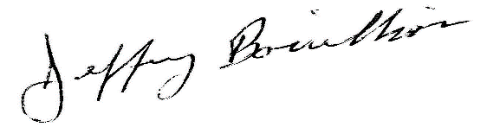
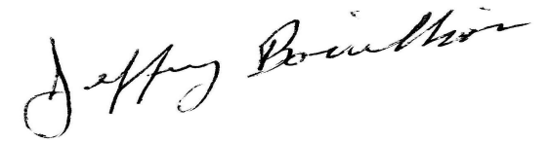

Jeffrey Bouillion
Chairman of the Board

PCU Board Biographies

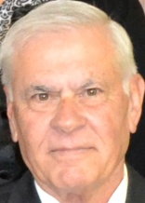
Ryness “Reno” Leblanc, Jr.
Mr. Ryness Leblanc, Jr is a retired Real Estate Agent from Rayne, Louisiana. He joined the credit union in 2001. He has served on the People’s Credit Union Board of Directors from 2008 to present. He currently serves as Vice Chairman of the board from 2017 to present. He has previously served on the board of various other organizations around Acadia Parish.
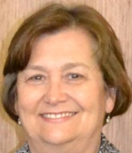

Rhonda Broussard
Mrs. Rhonda Broussard is the former owner/operator of Radio Shack and is from Rayne, Louisiana. She joined the credit union in 1987. She previously served on the Supervisory Committee from 2011 to 2012. She has served on the People’s Credit Union Board of Directors from 2012 to present.

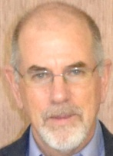
Michael Reynolds
Mr. Michael Reynolds is retired from Baker Hughes as a Systems Analyst. He is from Rayne, Louisiana. He joined the credit union in 1992. He has served on the People’s Credit Union Board of Directors from 2013 to present. He is a lifetime member of the Saint Leo IV Holy Name Society.

PCU Supervisory Committee Biographies

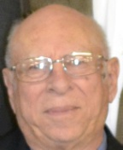

James Thibodeaux

Mr. James Thibodeaux is currently employed by Expressions in Rayne and is from Rayne, Louisiana. He joined the credit union in 2009. He has served on the Supervisory Committee from 2012 to present. He is a member of numerous other organizations both in Rayne and Acadia Parish.

PCU Credit Committee Biographies
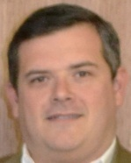

Robert D. Credeur, Jr.

Mr. Robert D. Credeur, Jr. is the owner/operator of Chef Roy’s in Rayne and is from Rayne, Louisiana. He joined the credit union in 2006. He has served on the Credit Committee from 2013 to present.

